**Assignment-2** : Create 3 VPC’s and attach to transit gateway

* Search VPC in search bar go to VPC click on Create VPC

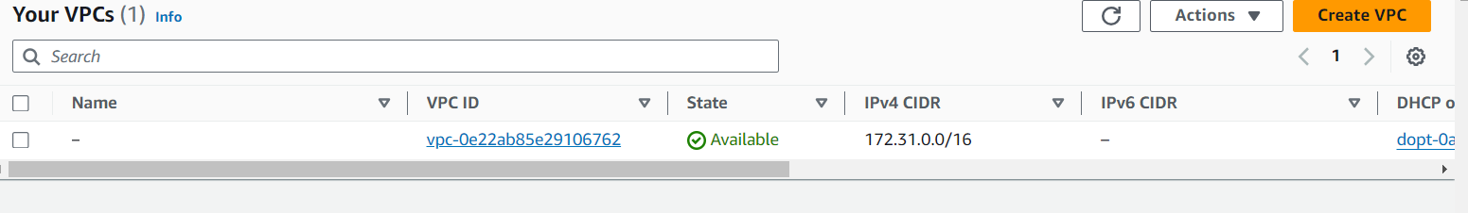

* Enter VPC name , IPV4 CIDR and click on Create VPC

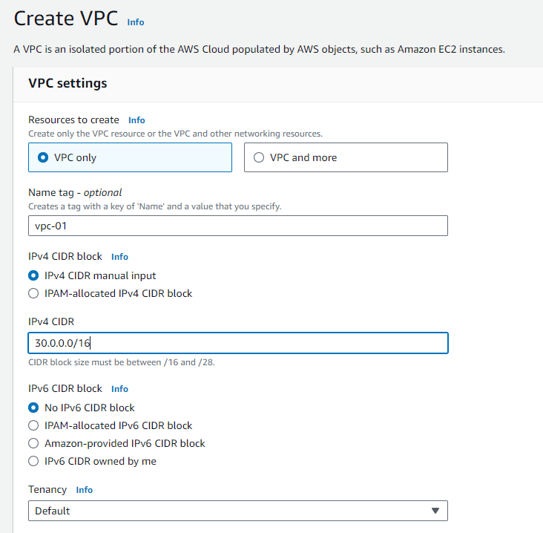

Create 3 VPC’s as shown in below

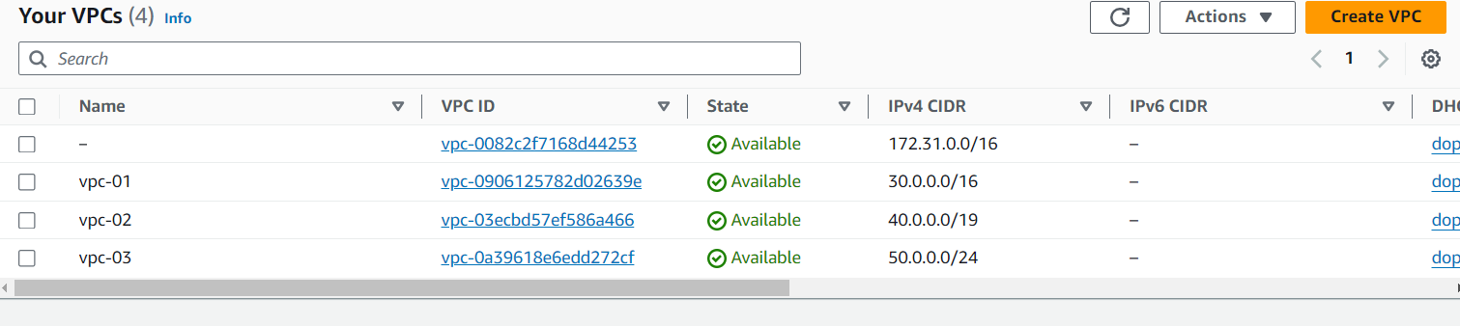

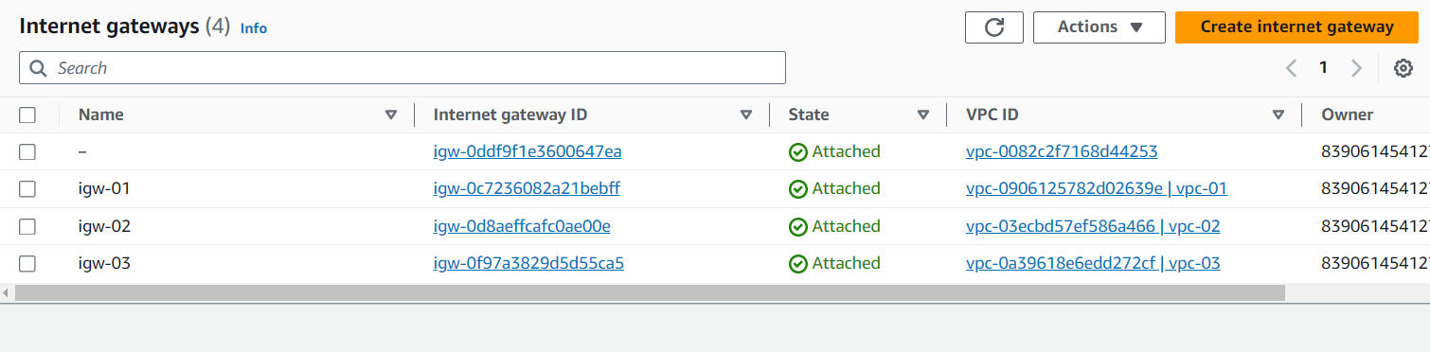

Create 3 route tables

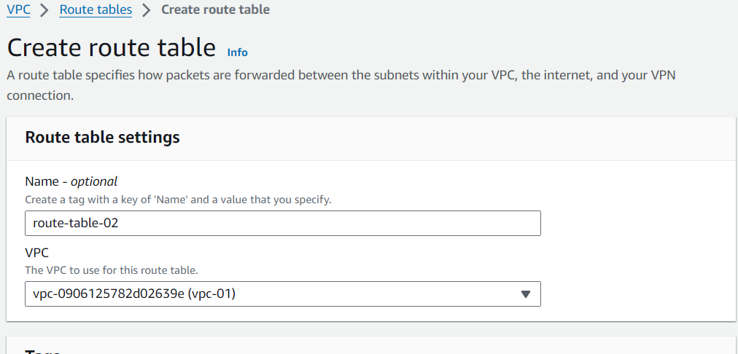

Click on route tables – click on edit routes

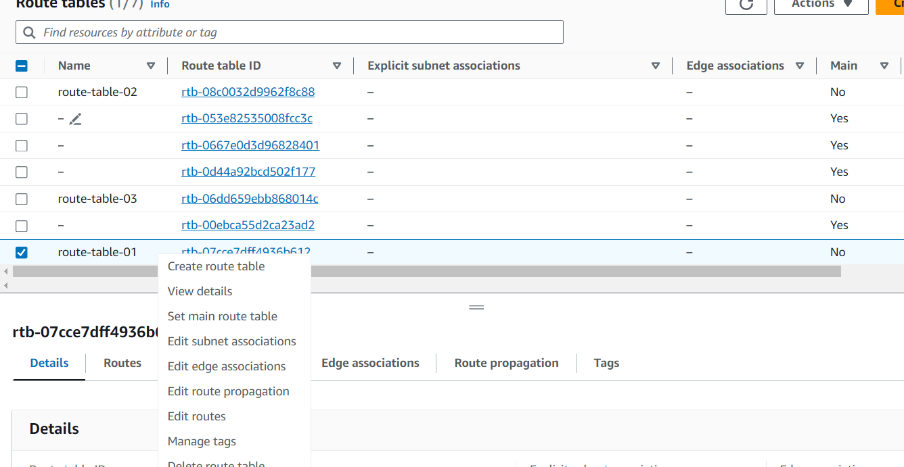

For route table-01 , Select the internet gateway-01 , similarly for route-table-02 and route-table-03

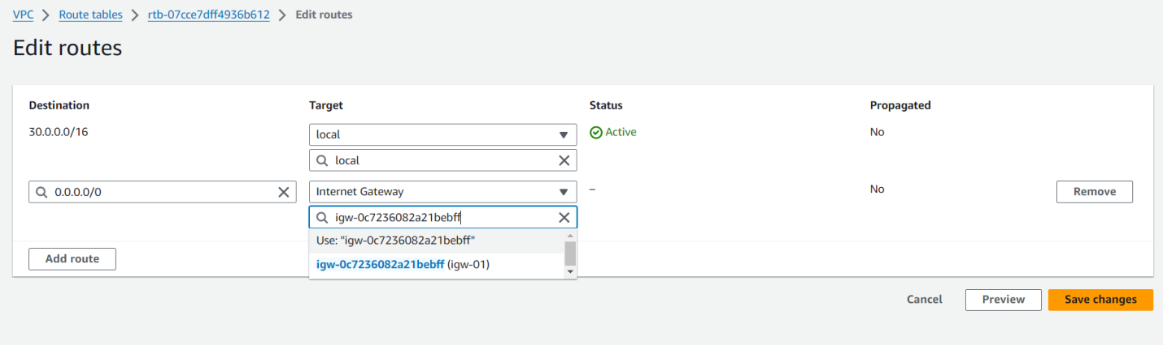

Click on edit subnet associations for every route table

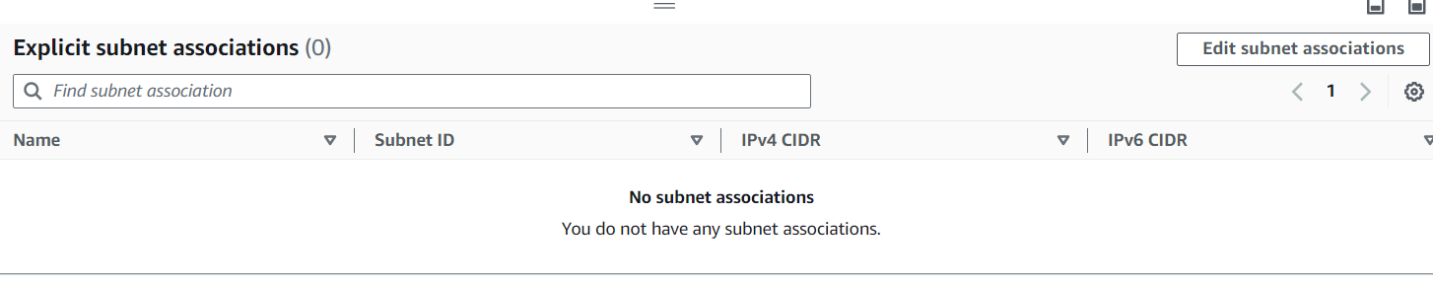

Create Transit gateway

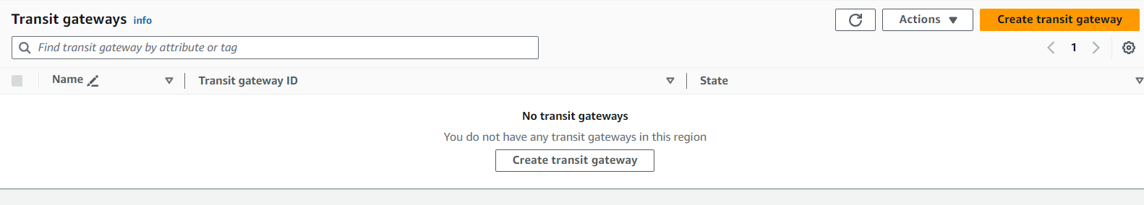

Click on transit gateway attachments

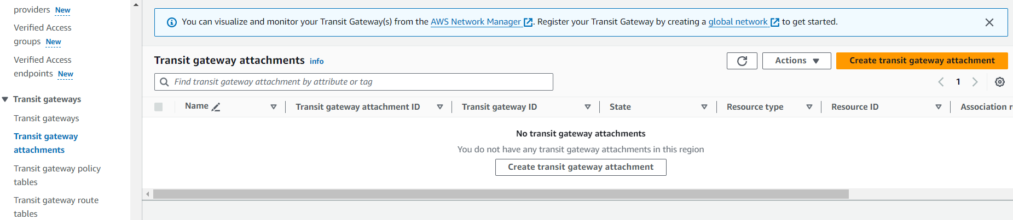

For transit-gateway-01 select VPC-01 , similarly transit-gateway-02 select VPC-02 , and transit-gateway-03 select VPC-03

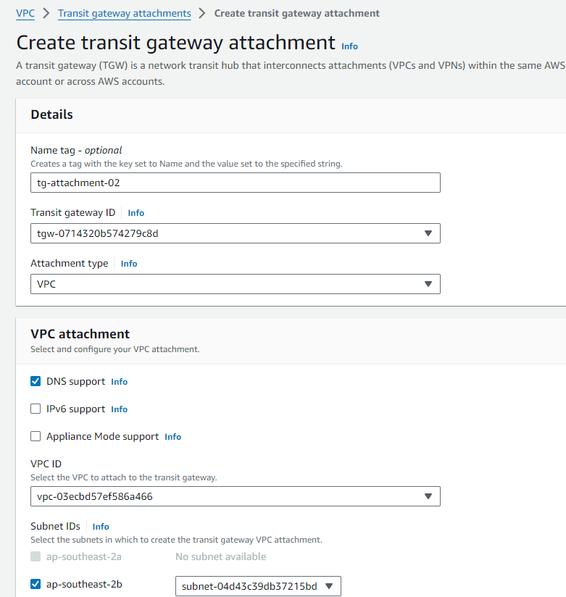

Now We have created 3 transit gateway attachments

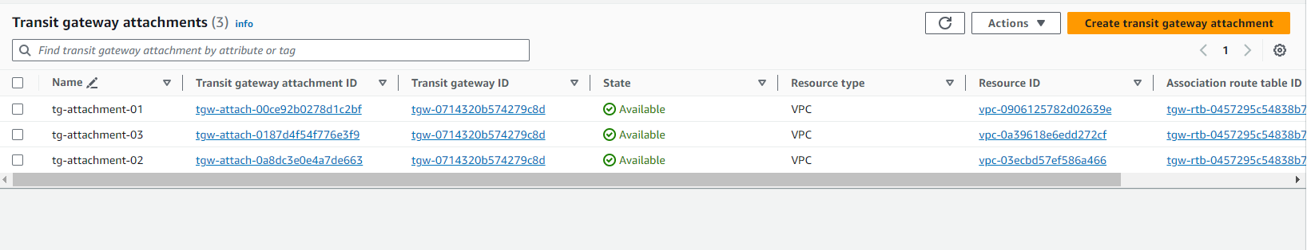

* Here go to route tables -> click on route-table-01 -> edit routes

Here now we are in route table -1 it’s destination is 30.0.0.0/16. So we have to give another 2 IPV4 addresses as destination.

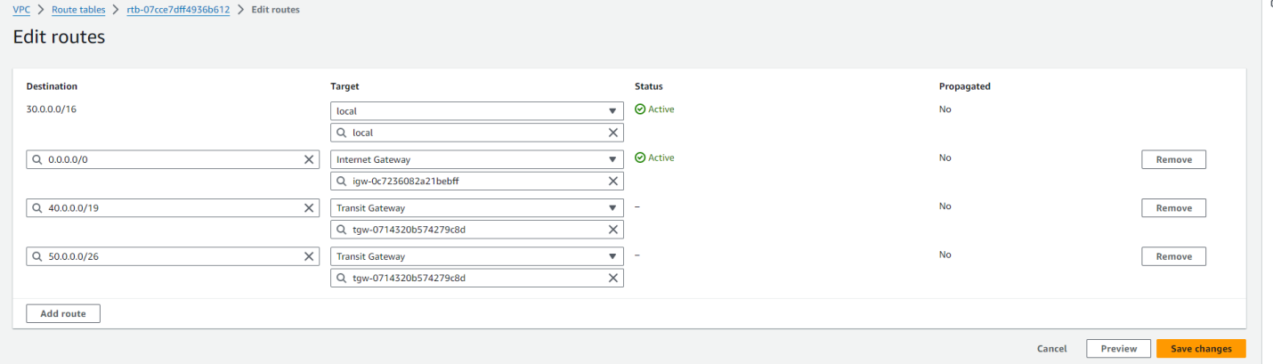

For route-table-02

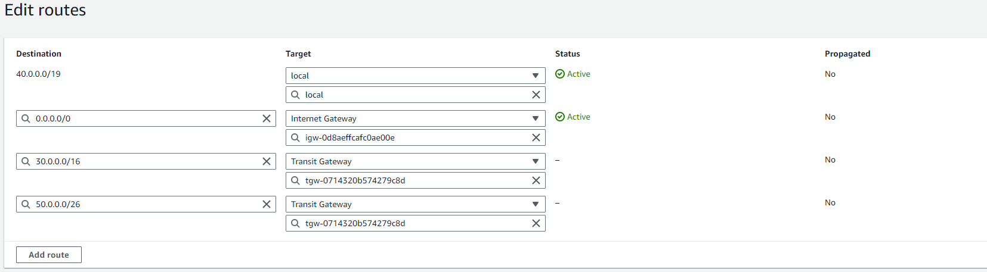

For route-table-03

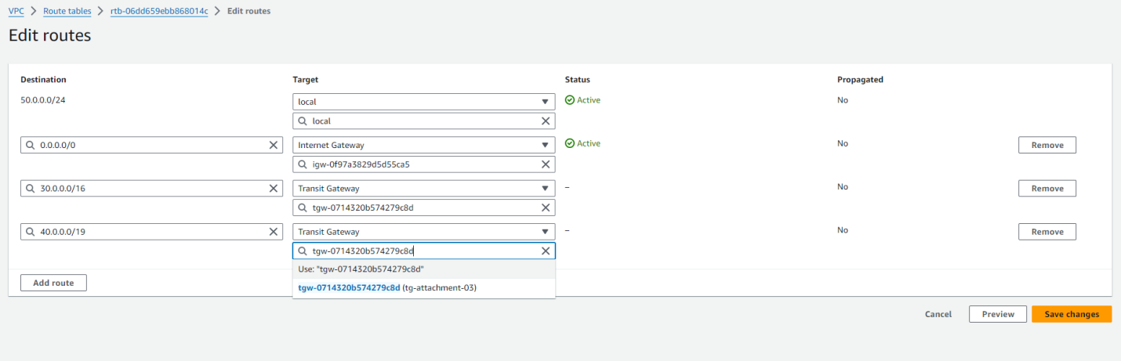

Now we are going to launch 3 ec2 instances

Click on launch instance

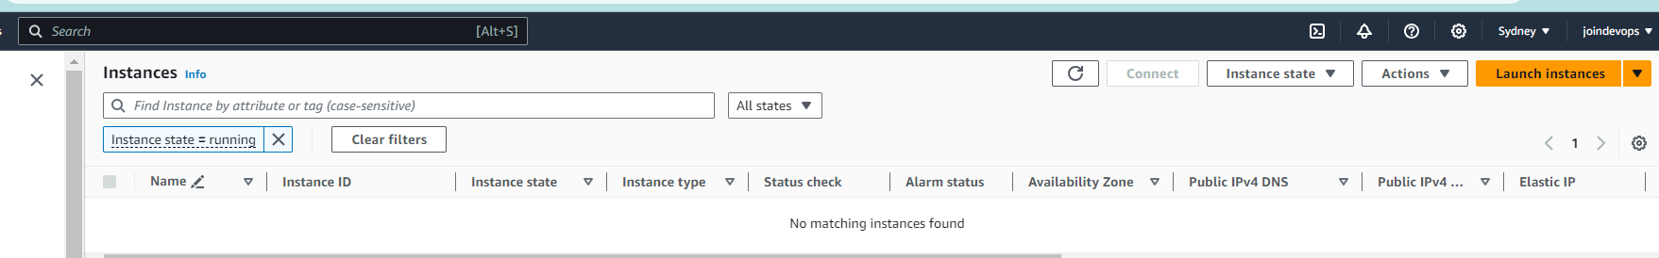

In security group select http instead of ssh

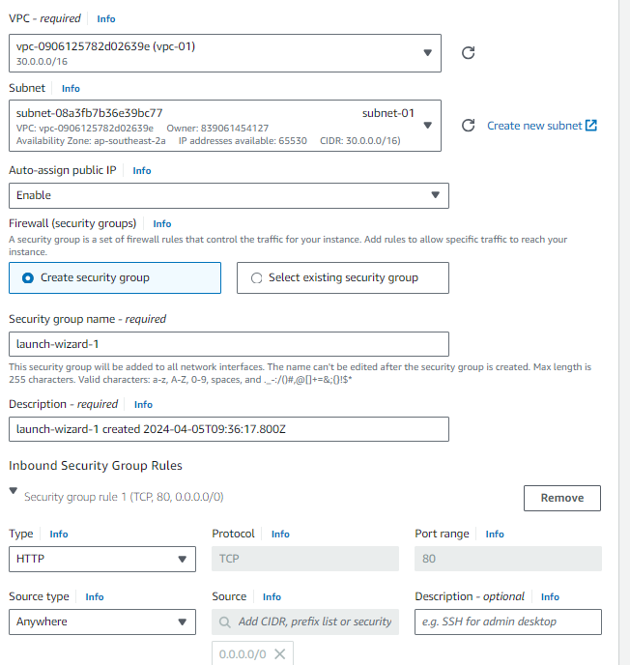

Click on launch instance

Now

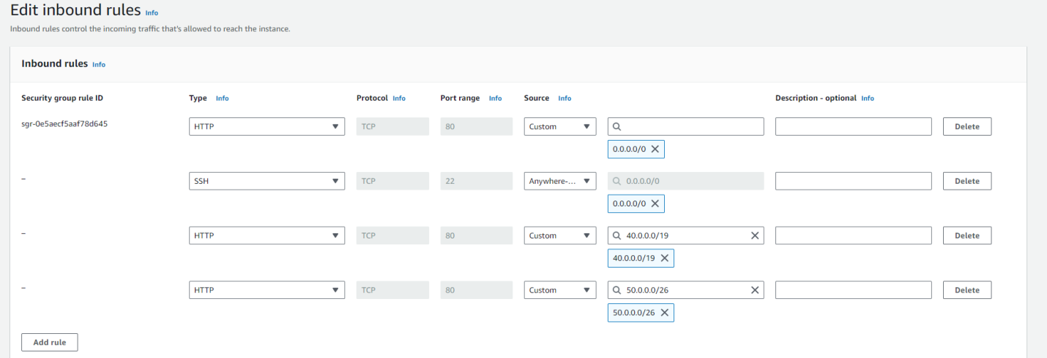

Now select SSH with 0.0.0.0/0

HTTP with another 2 IPV4 addresses and click on save changes.

Similarly do for other 2 instances.

For instance-2

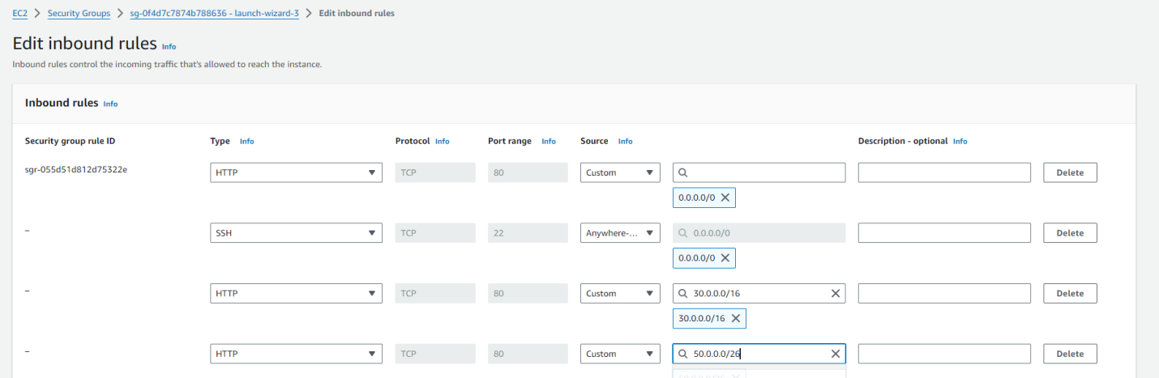

For instance-3

Now we are launching the instance. Install the nginx

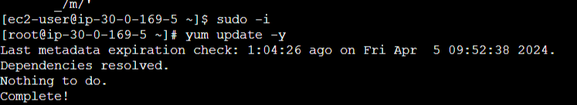

Now go to usr/share/nginx/html. Remove index.html file . create the same file. 

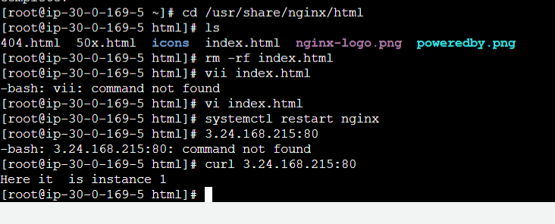

Similarly do it for instance 2

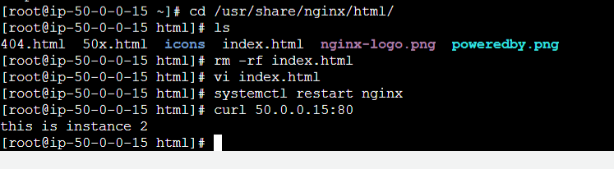

Instance 3 :

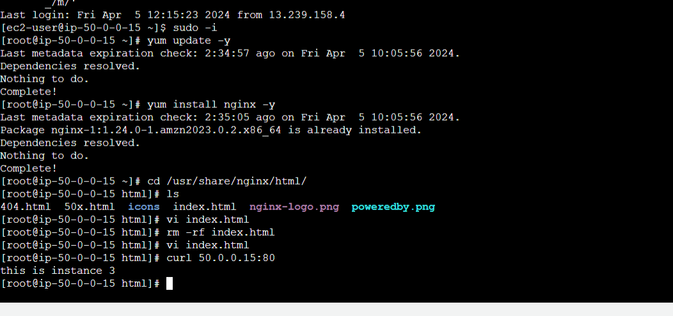

Now here in instance 3 we are using first instance private address

We can able to see data

So Transit gateway is done

